**Ingredients**

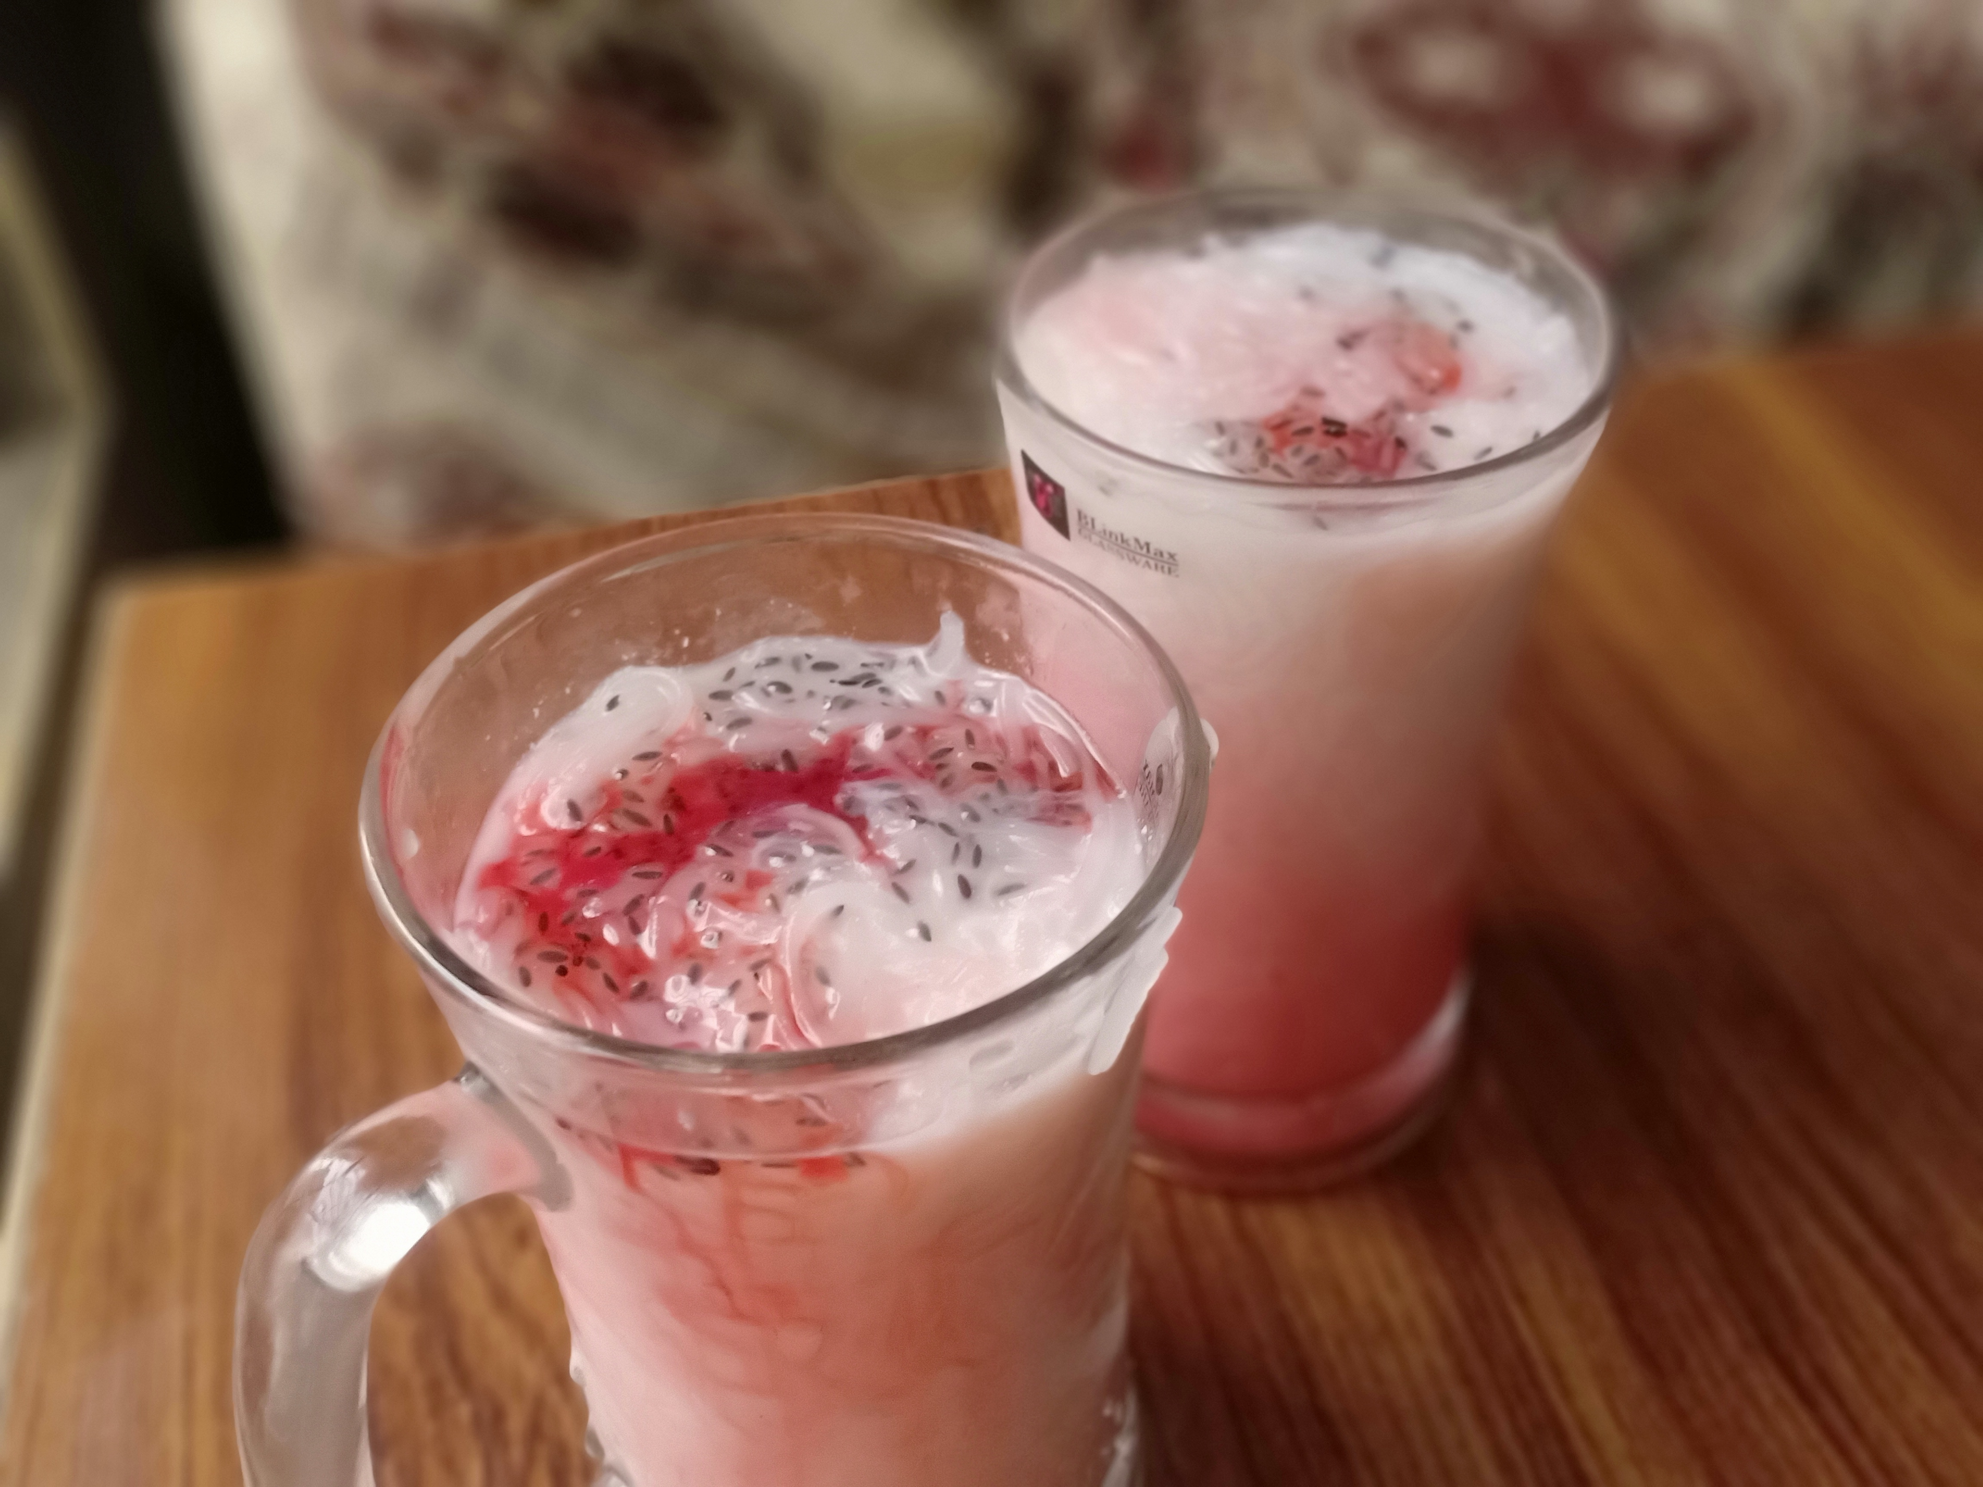

* 4 liter water
* 2 liter ice
* 0.5 kg nakhasta /ararot
* 1/4 cup optional hia seed / tuk malanga
* 1 liter chilled milk
* 1 cup jam-e-shiri

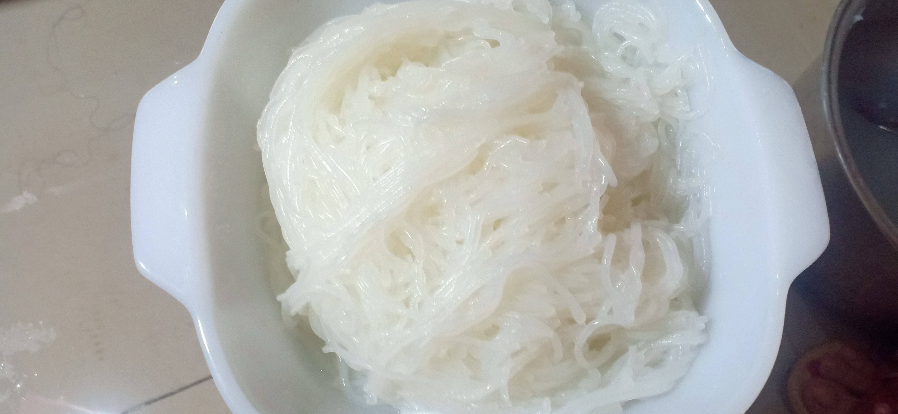

**Recipe**

* Add 2 liter water , ice in a bowl and keep it aside.
* Add nakhasta and water in pan and stirr it for 8-10 minutes untill it for some gluey structure.
* NOw pass it from strain placed over the cold ice water bowl.
* Add milk , jam-e-shiri ,hia seed / tuk malanga , falooda noodles in glass and it is ready to serve .